Logo image: PixelQuest Gaming logo
PixelQuest Gaming
Level Up Your Play!
Hero image: Exciting in-game battle scene (linked)
About PixelQuest
PixelQuest Gaming is your gateway to epic adventures, PvP battles, and co-op quests—every day.
Join our community to access exclusive tournaments, in-game rewards, and custom leaderboards.
Membership Plans & Pricing
How it should look like:
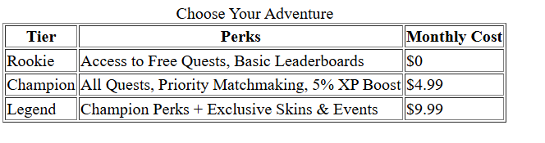
Choose Your Adventure:
- Rookie Plan
- Perks: Access to Free Quests, Basic Leaderboards
- Monthly Cost: $0
- Champion Plan
- Perks: All Quests, Priority Matchmaking, 5% XP Boost
- Monthly Cost: $4.99
- Legend Plan
- Perks: Champion Perks + Exclusive Skins & Events
- Monthly Cost: $9.99

Contact Us
support@pixelquest.gg
123 Gamer Lane
Toronto, ON
M5V 2B6
© 2025 PixelQuest Gaming

